Linux Commands
- Top- used to monitor system performance in real time.
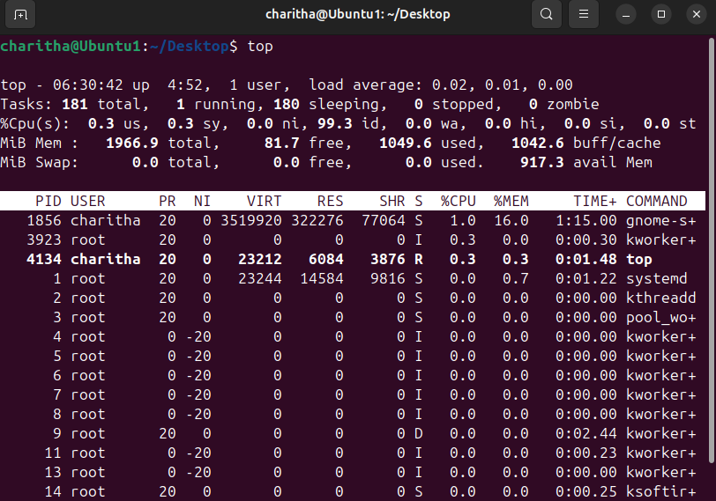

- Ps -ef – shows all the running process with full details
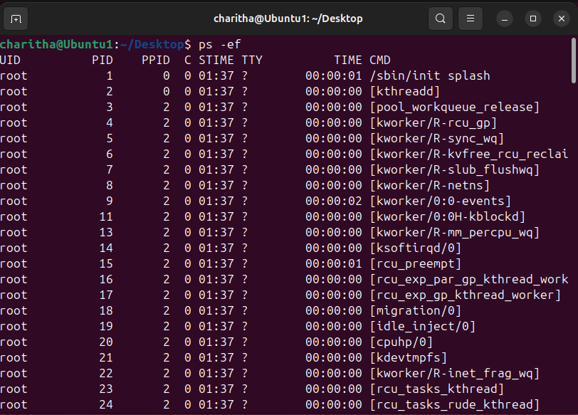

- Ps -ef | grep nginx – shows only ngnix related process (filter specific process)
| means pipe it is used to connect two commands. It takes output of one command and gives input to another command.
- Sudo apt install nginx - This command is used to install nginx software in ubuntu using the apt package manager with admin permission.

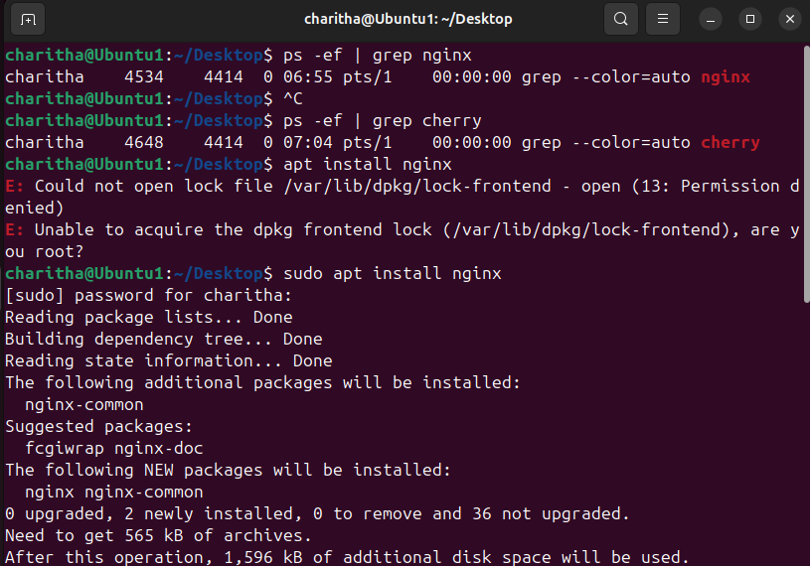

- Sudo systemctl start nginx- After the installing nginx, we need to start the service using sysemctl command.
- Sudo systemctl ststus nginx- To check whether nginx is running or not, we use status.
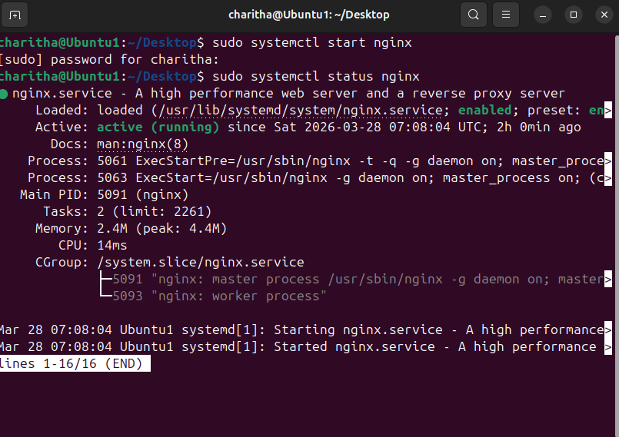

- ps -ef | grep nginx- Shows nginx process and Displays PID (Process ID)
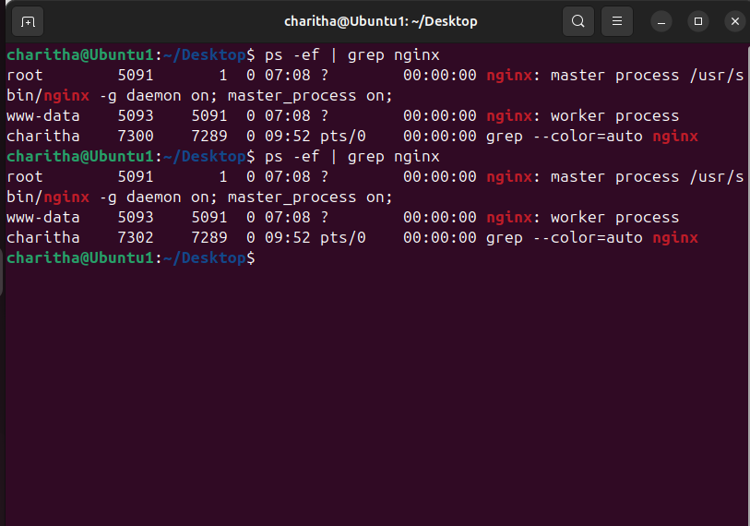

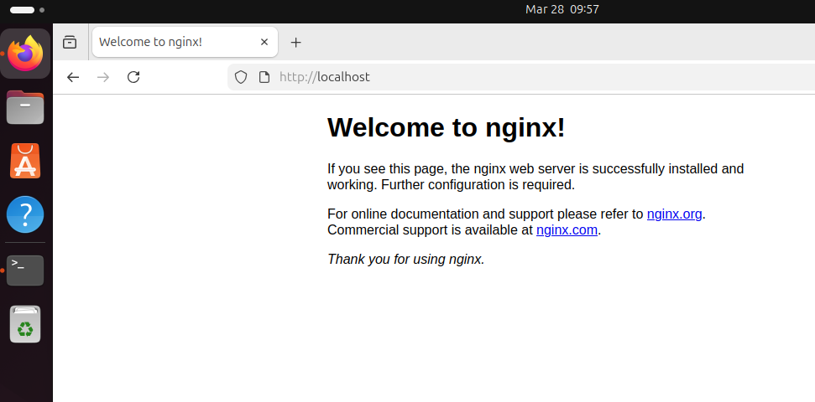

- sudo systemctl stop nginx- Stops service properly and Recommended method After stop: ps -ef | grep nginx → no output localhost will not working.
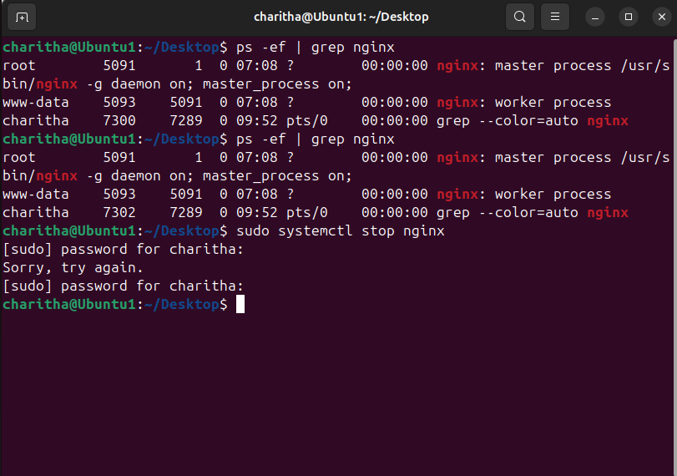
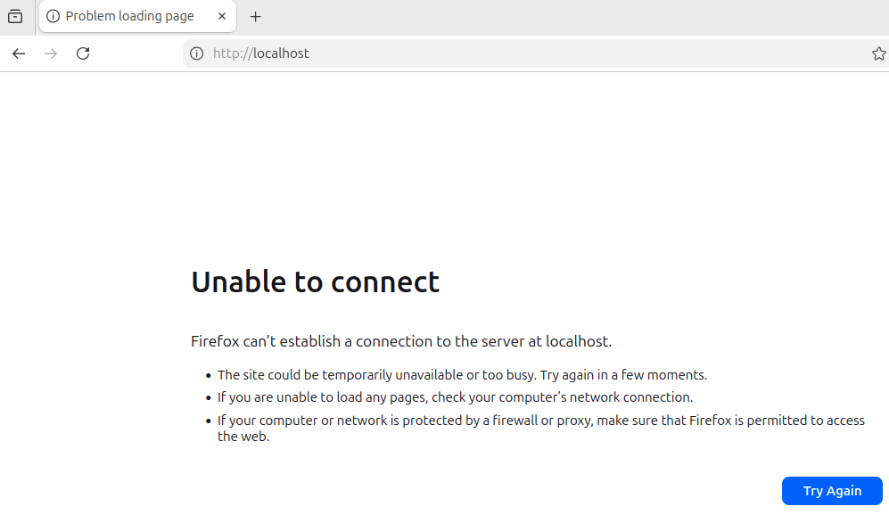

- sudo kill -9 pid - Kill = force stop it may cause data/config issues. Use only as last option
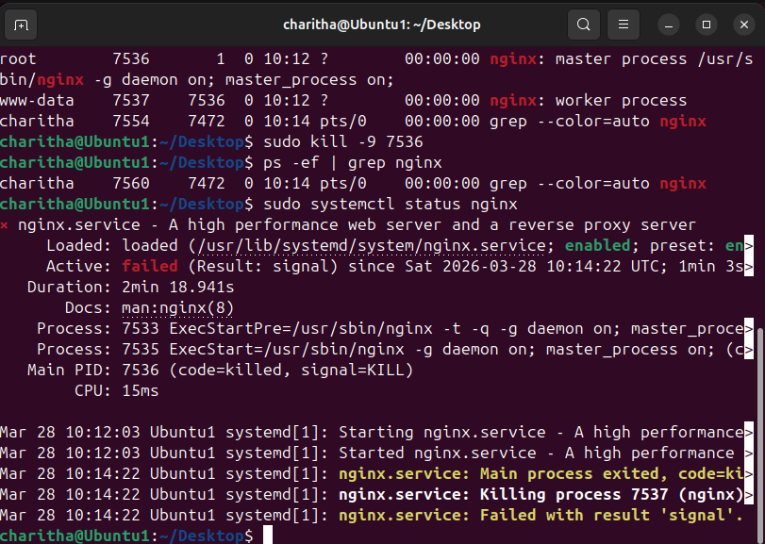
- TAR- combine many files into one and compression
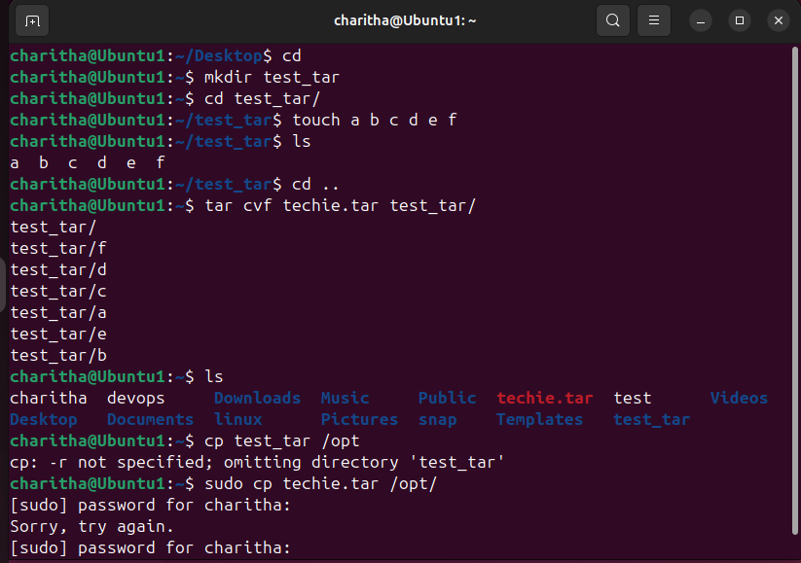
- Untar- means extracting files from a .tar file

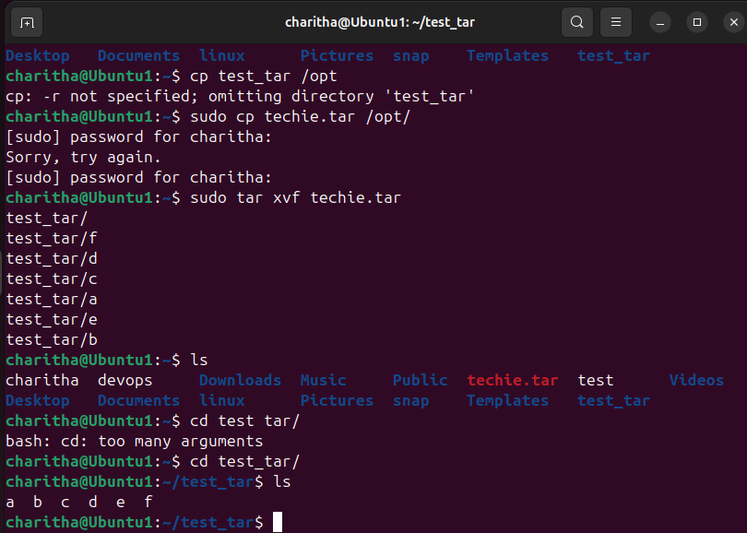

- id shows the current user’s ID and group details
- uname displays system or kernel information (use -a for full details) user name
- cat /etc/os-release gives OS details like name and version
- cat /proc/cpuinfo shows CPU details like processor, cores, and speed

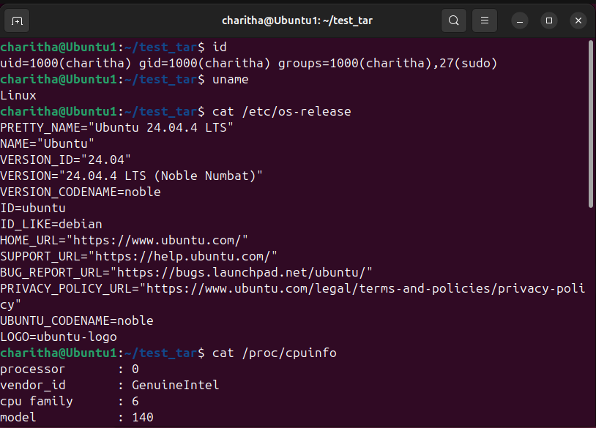

- du -h shows file/folder sizes in readable format (KB, MB)
- df -h shows disk space usage (used and free space)
- du -sk * shows size of each file/folder in KB
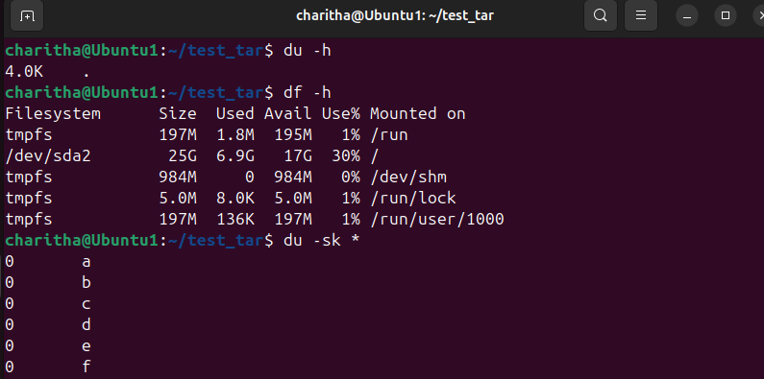
- ip -a shows IP address and network details in Linux
- ipconfig shows IP address and network details in Windows
